Link to Wisdom EDRM – Foster Carer

Find your carer and click on the Carer/Adopter tab
Click on the link ‘View Full Foster Carer Details’
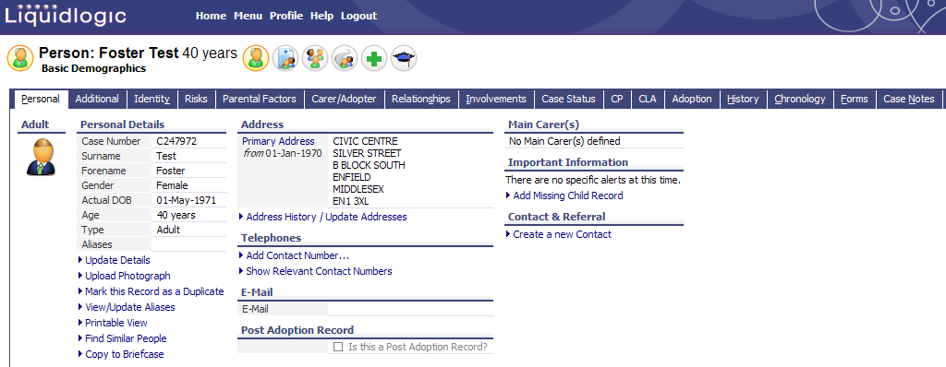

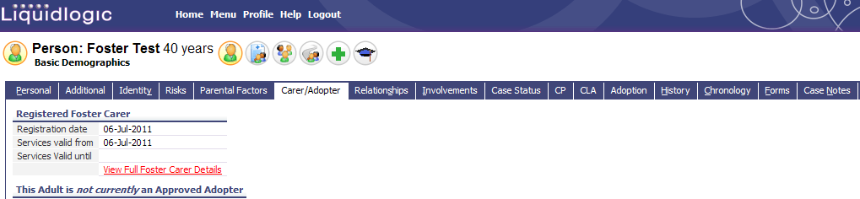
Click on the Forms Tab

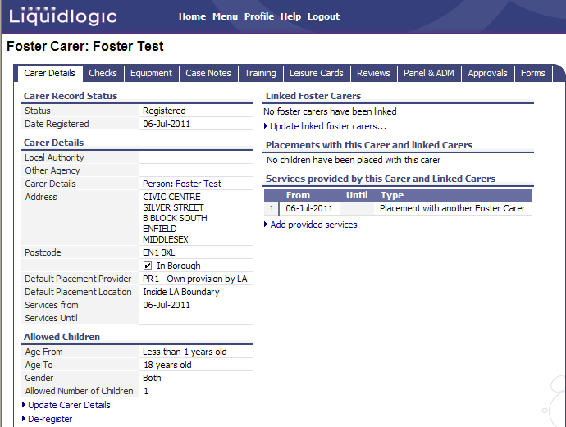

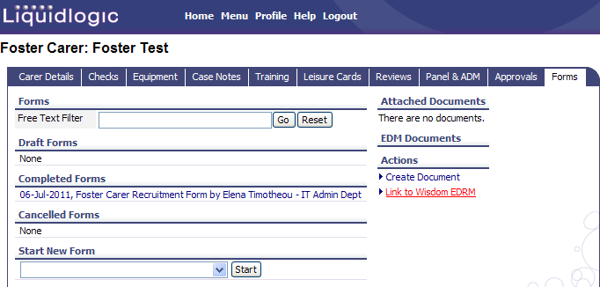
The link to Wisdom EDRM is located under the Actions Heading – Click on ‘Link to Wisdom EDRM’

Wisdom EDRM will then be launched, you will be presented with the following screen.
You will now be able to navigate to the sub-folders to view or upload new documents into Wisdom EDRM.

